Mrs. Princia Koronado – Co-Founder & Women’s Rights Advocate
Nationality: Central African Republic & Mauritania
Title: Co-Founder, Action Pour le Développement de la Femme et de l’Enfant (APDFE)
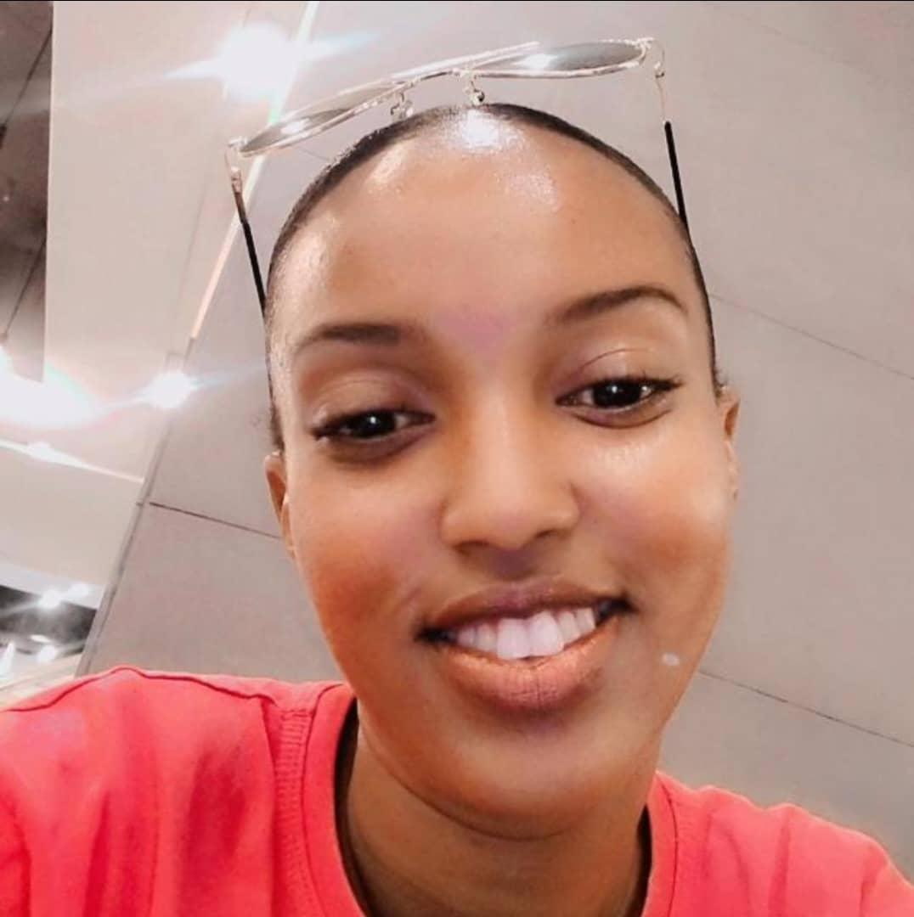
Mrs. Princia Koronado is a seasoned women’s rights advocate, community leader, and educator with over a decade of dedicated service to the advancement of vulnerable women and girls in the Central African Republic. With a professional background in education and community health, Mrs. Koronado has spent more than ten years working as a primary school teacher across four different schools in conflict-affected regions of her country, where she championed access to inclusive and quality education for young girls.
Beyond the classroom, Mrs. Koronado has held several community leadership roles within local authorities, contributing to grassroots governance and social development. Her longstanding commitment to public service is further reflected in her work as a community health worker, where she provided critical support to women and adolescent girls with limited access to Sexual and Reproductive Health and Rights (SRHR) services. In this role, she also delivered psychosocial support to survivors of gender-based violence, offering both care and advocacy for those most affected by conflict and systemic exclusion.

Mrs. Koronado holds a Bachelor’s Degree in Teaching from the University of Bangui and continues to be recognized for her deep-rooted compassion, resilience, and leadership in fragile contexts. Her personal experience as a survivor of intercommunal violence has shaped her conviction and dedication to transformative community service.
In 2019, Mrs. Koronado co-founded Action Pour le Développement de la Femme et de l’Enfant (APDFE) alongside Mr. Adelithe Mugabo, a fellow survivor and human rights activist from Rwanda. Together, they established APDFE as a continental platform for empowerment, protection, and dignity for women and children in post-conflict and humanitarian settings.
Today, Mrs. Koronado continues to lead and inspire with a mission to make a lasting, positive impact on the lives of women and children across Africa.

